1. **Agenda**:
   1. Unit Test Repository Layer class.
2. **@DataJpaTest**:
   1. Spring Slice Test (Jatin)
   2. It will instantiate H2DB (as we configured in the app through spring boot h2b starter) and will execute the SQLs from data.sql file.
   3. Basically, this annotation does everything as @SpringBootApplication does but related to Repository Layer.   
      So, it means it will not instantiate controller layer and business layer.
3. @DataJpaTest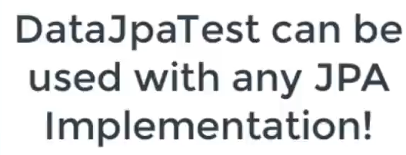
   1. Graphical user interface, text, application

      Description automatically generated
   2. 